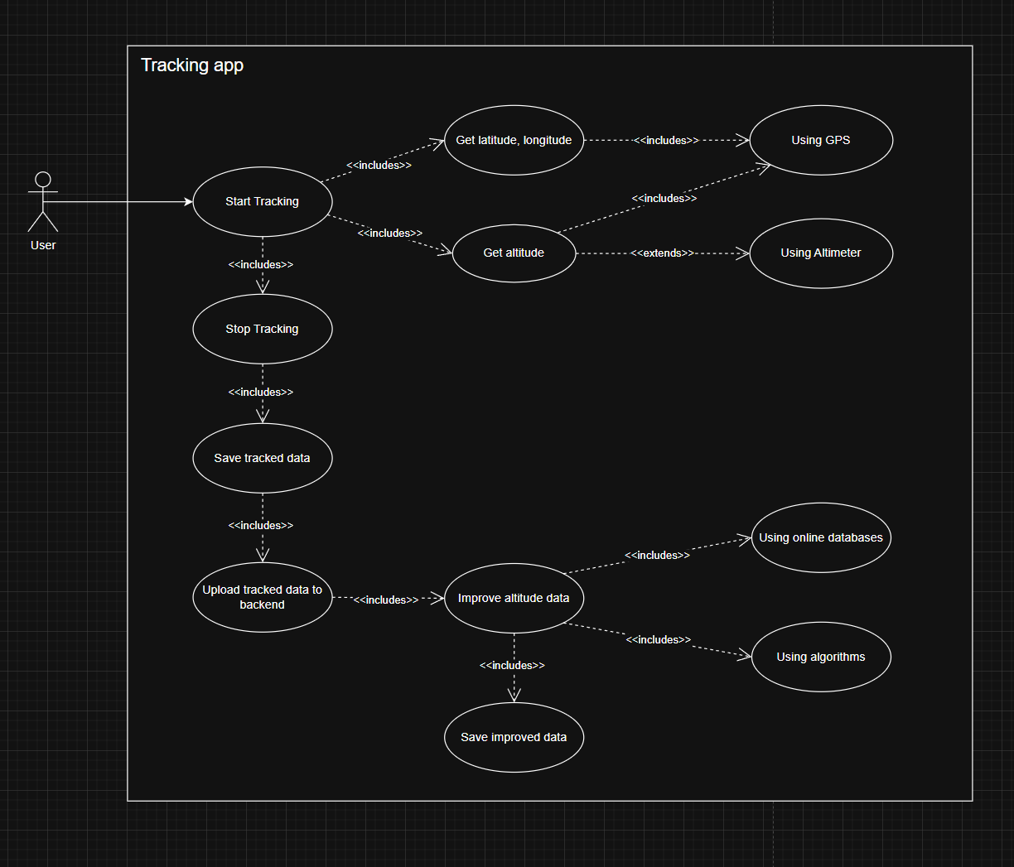

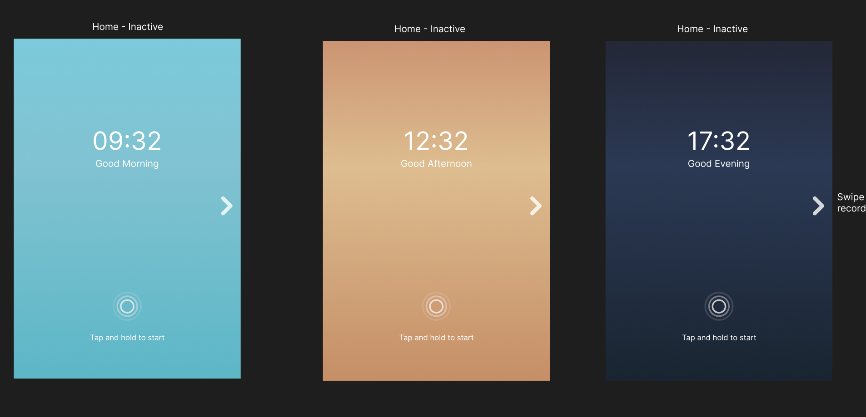

|  |  |
| --- | --- |
| Description | The system displays one of the screens shown upon start-up (home screen), depending on the time of day. |
| Precondition | The user starts the application. |
| Sequence | N/A |
| Postcondition | The user has the choice to start a recording (tap and hold) or view any previous recordings (swipe left). |
| Comments | * Colours here aren’t final and just suggestions for morning / afternoon / evening. It’s also possible to just have a grayscaled theme (see below use cases). * The “swipe left to see recordings” could be replaced by having an icon in the top right corner. |

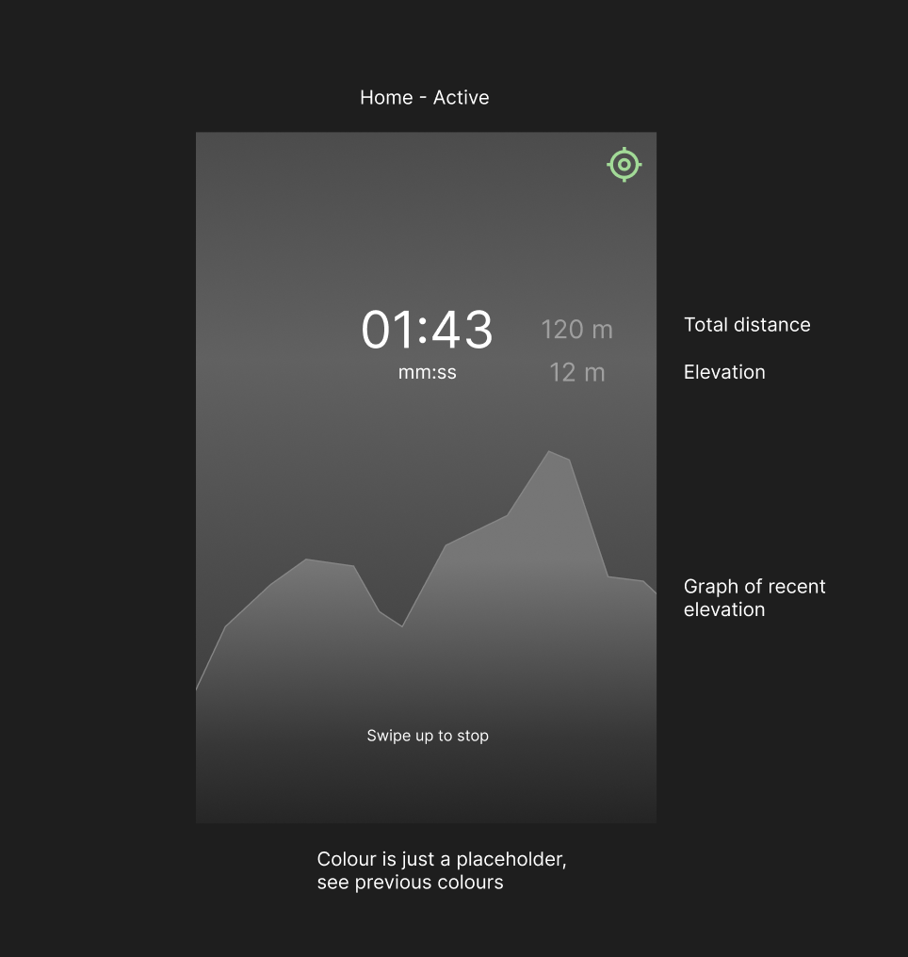

<<USE CASE, TRACK RECORDING>>

|  |  |
| --- | --- |
| Description | The application records a track. |
| Precondition | The application is in the idle state (on the home screen) and is not in the recording state. |
| Sequence | * While in the idle state, the user taps and holds the circle shown on the screen (see previous use case). * The application starts recording the current position and elevation through GPS (and altimeter if applicable), displays the current time, distance and elevation through text and a graph. |
| Postcondition | Swiping up results in the termination of the recording, saves the recorded data and returns to the idle home screen. |
| Comments | * The colour here is grayscaled, which can either be in the final design or replaced by the alternating colours shown in the previous use case. * The top right icon displays the current GPS signal strength. |

<< USE CASE, SAVING AND UPLOADING DATA >>

|  |  |
| --- | --- |
| Description | The application saves the recorded track. |
| Precondition | The application was previously recording. |
| Sequence | * While recording, the user swipes up to terminate the recording and saves the track. * The application saves the data locally onto the device. * The application uploads the data to the backend. |
| Postcondition | The user can view the saved data and is visible on the backend. |
| Comments | N/A |

|  |  |
| --- | --- |
| Description | The application displays a list of all recordings. |
| Precondition | The application is in the idle state and is not actively recording a track. |
| Sequence | * While in the idle state, the user swipes towards the left direction. |
| Postcondition | The user can inspect any of the listed recordings or return to the home screen (back button). |
| Comments | * The colour here is grayscaled, which can either be in the final design or replaced by the alternating colours shown in the first use case. * The button on the top left could be replaced with swiping towards the right to return to the home screen. |

|  |  |
| --- | --- |
| Description | The application displays more details about a selected recorded track. |
| Precondition | There exists at least one recorded track. |
| Sequence | * While in the list of all recordings (see previous use case), the user clicks on any of the displayed recordings. |
| Postcondition | The user has the option to rename, share, delete, or export the track to GPX. |
| Comments | * The ‘share’ button and ‘export to GPX’ button could be merged. * The presence of a altimeter is shown here as well (the last icon, next to ‘Has’). This icon could be changed if it isn’t clear enough. |

<<USE CASE, POST-PROCESSING DATA>>

|  |  |
| --- | --- |
| Description | Tracks on the backend are processed. |
| Precondition | The application client(s) has uploaded tracks to the backend. |
| Sequence | * Upon track upload, the backend uses data from external databases and/or smoothening algorithms to correct the elevation according to the current position of the user. |
| Postcondition | The data can be analyzed further and visualized through graphs. |
| Comments | * Figure out backend server hosting solution. |